Case Study Report



**Tech Saksham**

Data Analytics with Power BI

**“ANALYSIS OF COMMERCIAL ELECTRICITY CONSUMPTION IN INDIAN STATE”**

**“SRI PARAMAKALYANI COLLEGE”**

|  |  |
| --- | --- |
| **NM ID** | NAME |
| E6FB133114AA8A0AB7E4B09FDABD7BF7 | G.SURESH GOPINATH |

Trainer Name umamaheswari

|  |  |
| --- | --- |
| Master Trainer : Umamaheswari |  |
|  |  |
|  |  |

**ABSTRACT**

Real-time analytics is a special kind of big data analytics in which data elements are required to be processed and analysed as they arrive, in real-time. It is important in situations where real-time processing and analysis can deliver important insights and yield business value. This chapter provides an overview of current processing and analytics platforms needed to support such analysis as well as analytics techniques that can be applied in such environments. The chapter looks beyond traditional Event Processing System (EPS) technology, considering a broader big data context that involves ‘data at rest’ platforms and solutions. The chapter includes a case study showing the use of EventSwarm complex event processing engine for a class of analytics problems in finance. The chapter concludes with several research challenges, such as the need for new approaches and algorithms required to support real-time data filtering data exploration statistical data analysis and machine learning

.

**INDEX**

|  |  |  |
| --- | --- | --- |
| **Sr. No.** | **Table of Contents** | **Page No.** |
| 1 | Chapter 1: Introduction | 4 |
| 2 | Chapter 2: Services and Tools Required | 6 |
| 3 | Chapter 3: Project Architecture | 7 |
| 4 | Chapter 4: Modeling and Result | 9 |
| 5 | Conclusion | 18 |
| 6 | Future Scope | 19 |
| 7 | References | 20 |
| 8 | Links | 21 |

**CHAPTER 1**

**INTRODUCTION**

* 1. **Problem Statement**

The statement of the problem is one of the first things that a colleague or potential client will read. With the vastness of the information available at one’s fingertips in the online9 world, your work may have just a few seconds to draw in a reader to take a deeper look at your proposal before moving on to the next option. It explains quickly to the reader, the problem at hand, the need for research, and how you intend to do it.

A strong, clear description of the problem that drew you to your research has to be straightforward, easy to read and, most important, relevant. Why do you care about this problem? How can solving this problem impact the world? The problem statement is your opportunity to explain why you care and what you propose to do in the way of researching the problem.

* 1. **Proposed Solution**

Your proposed solution section should offer your solution specifically, with enough detail so that your reader understands exactly what you’re proposing. Indicate how your proposed solution will solve the problem and provide tangible benefits. Specifically, explain how it will meet the objectives and abide by the constrains outlined in the problem definition. Give concrete examples. Show the specific differences between “how things are now” and “how they could be.” Be as logical as possible. Emphasize the results, benefits, and feasibility of your proposed idea. Also use your criteria, developed as you considered possible solutions, to anlayze your proposed solution against the other possible solutions. This is where your pros and cons come in – you can use your brainstorming and idea development to create the evidence to back up your particular solution and prove that it’s better than the others. Show that your proposed solution is more cost effective, easier to implement etc.than other proposed solution

* 1. **Feature**
* **Real-Time Analysis**: Real-time analysis is the discipline that applies logic and mathematics to data to provide insights for making better decisions quickly. For some use cases, real time simply means the analytics is completed within a few seconds or minutes after the arrival of new data.
* **Customer Segmentation**: Customer segmentation is the process by which you divide your customers up based on common characteristics – such as demographics or behaviours, so your marketing team or sales team can reach out to those customers more effectively.
* **Trend Analysis**: Trend analysis is a methodology used in research to gather and study data for prediction-making about future consumer behavior based on the trend analysis of observed and recorded data from past and ongoing trends.
* **Predictive Analysis**: Predictive analytics is a branch of advanced analytics that makes predictions about future outcomes using historical data combined with statistical modeling, data mining techniques and machine learning.
  1. **Advantages**
* **Data-Driven Decisions**: The process is more objective and can be quickly evaluated according to the influence of the data on metrics
* **Improved Customer Engagement**: Customer engagement encompasses interest, loyalty, and commitment. All these factors are paramount to business growth. In short, an engaged customer is a happy and loyal customer, who is likely to stay on board and recommend your services to their friends, family, on public forums, and other word-of-mouth channels.
* **Increased Revenue**: Increased revenue from oil led to greater investment in agriculture.
  1. **Scope**

Project scope is a way to set boundaries on your project and define exactly what goals, deadlines, and project deliverables you'll be working towards. By clarifying your project scope, you can ensure you hit your project goals and objectives without delay or overwork.

**CHAPTER 2**

**SERVICES AND TOOLS REQUIRED**

**2.1 Services Used**

* **Data Collection and Storage Services**: Banks need to collect and store customer data in real-time. This could be achieved through services like Azure Data Factory, Azure Event Hubs, or AWS Kinesis for real-time data collection, and Azure SQL Database or AWS RDS for data storage.
* **Data Processing Services**: Services like Azure Stream Analytics or AWS Kinesis Data Analytics can be used to process the real-time data.
* **Machine Learning Services**: Azure Machine Learning or AWS SageMaker can be used to build predictive models based on historical data.

**2.2 Tools and Software used**

**Tools**:

* **PowerBI**: The main tool for this project is PowerBI, which will be used to create interactive dashboards for real-time data visualization.
* **Power Query**: This is a data connection technology that enables you to discover, connect, combine, and refine data across a wide variety of sources.

**Software Requirements**:

* **PowerBI Desktop**: This is a Windows application that you can use to create reports and publish them to PowerBI.
* **PowerBI Service**: This is an online SaaS (Software as a Service) service that you use to publish reports, create new dashboards, and share insights.
* **PowerBI Mobile**: This is a mobile application that you can use to access your reports and dashboards on the go.

**CHAPTER 3**

**PROJECT ARCHITECTURE**

**3.1 Architecture**

**USER FRONTEND BACKEND**

|  |  |  |
| --- | --- | --- |
|  | **HTML 5** | **NODEJS 14.0**  **Database** |

Here’s a high-level architecture for the project:

1. **Data Collection**: Real-time customer data is collected from various sources like bank transactions, customer interactions, etc. This could be achieved using services like Azure Event Hubs or AWS Kinesis.
2. **Data Storage**: The collected data is stored in a database for processing. Azure SQL Database or AWS RDS can be used for this purpose.
3. **Data Processing**: The stored data is processed in real-time using services like Azure Stream Analytics or AWS Kinesis Data Analytics.
4. **Machine Learning**: Predictive models are built based on processed data using Azure Machine Learning or AWS SageMaker. These models can help in predicting customer behavior, detecting fraud, etc.
5. **Data Visualization**: The processed data and the results from the predictive models are visualized in real-time using PowerBI. PowerBI allows you to create interactive dashboards that can provide valuable insights into the data.
6. **Data Access**: The dashboards created in PowerBI can be accessed through PowerBI Desktop, PowerBI Service (online), and PowerBI Mobile.

This architecture provides a comprehensive solution for real-time analysis of bank customers. However, it’s important to note that the specific architecture may vary depending on the bank’s existing infrastructure, specific requirements, and budget. It’s also important to ensure that all tools and services comply with relevant data privacy and security regulations.

**CHAPTER 4**

**MODELING AND RESULT**

**Manage relationship**

Management relationship refers to the strategies, processes, and tools used by businesses to build and maintain strong, long-lasting relationships with customers. It involves understanding customers’ needs, preferences, and behaviors to deliver personalized experiences, provide timely support, and foster customer loyalty. Effective relationship management helps businesses drive customer satisfaction, retention, and ultimately, business growth.

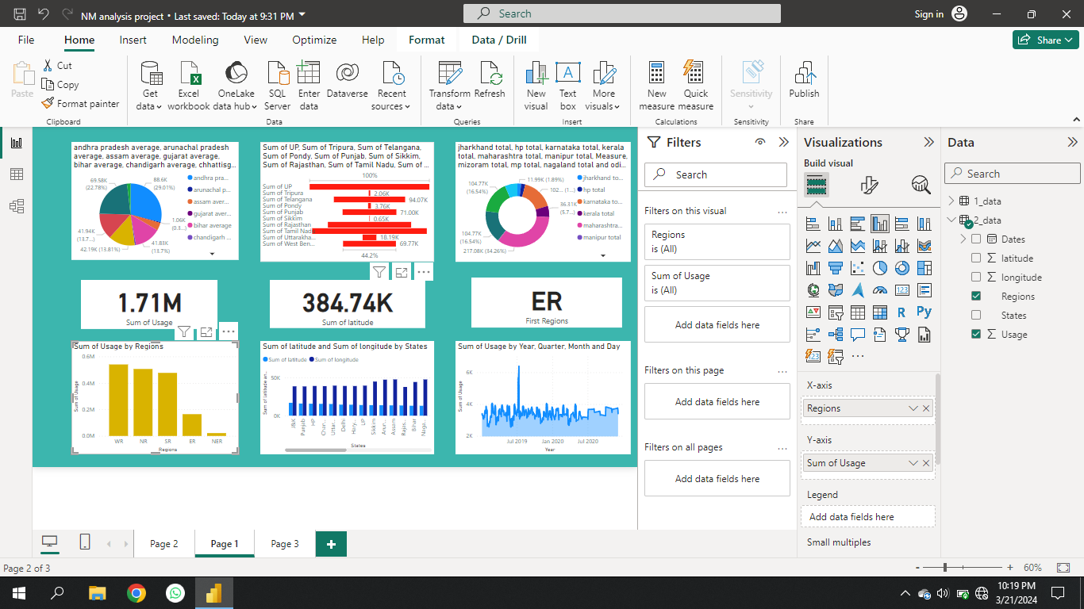

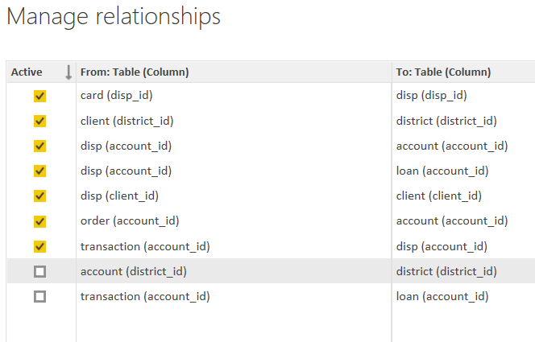

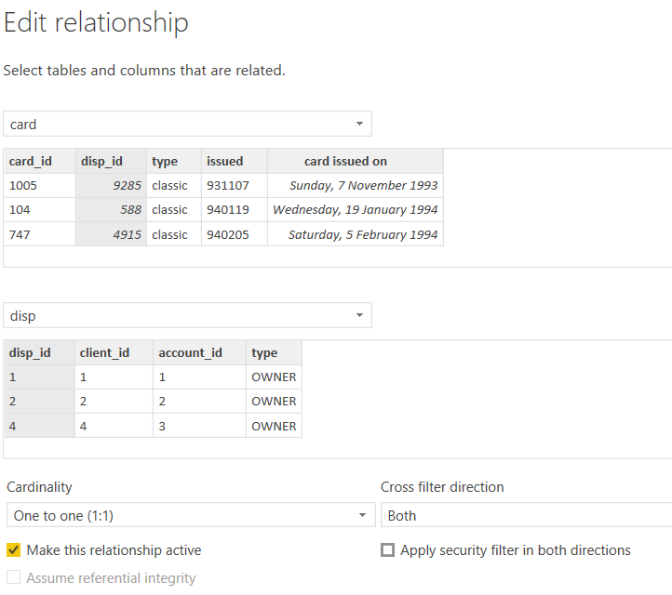

**Modelling for Gender and Age data**

Notice that the Gender and age of the client are missing from the data. These can be formulated from the birth number YYMMDD where at months (the 3rd and 4th digits) greater than 50 means that client is a Female. We can create a column for Gender.

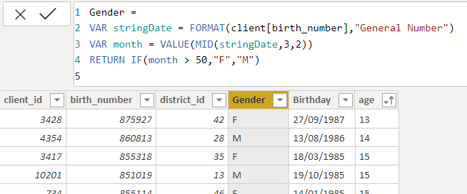

For birthday, we need to reduce the birth month of the female by 50 and then change the date format to DD/MM/YYYY adding 1900 to the year.

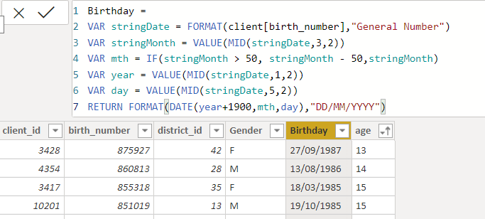

For Age, we shall assume it is year 1999 as explain previously and use it to minus from the birth year.

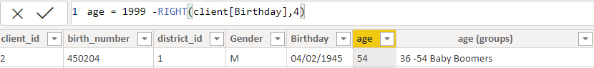

**Replacing values**

Set some fields to English for easy understanding, we replace values to English with the Power Query Editor.

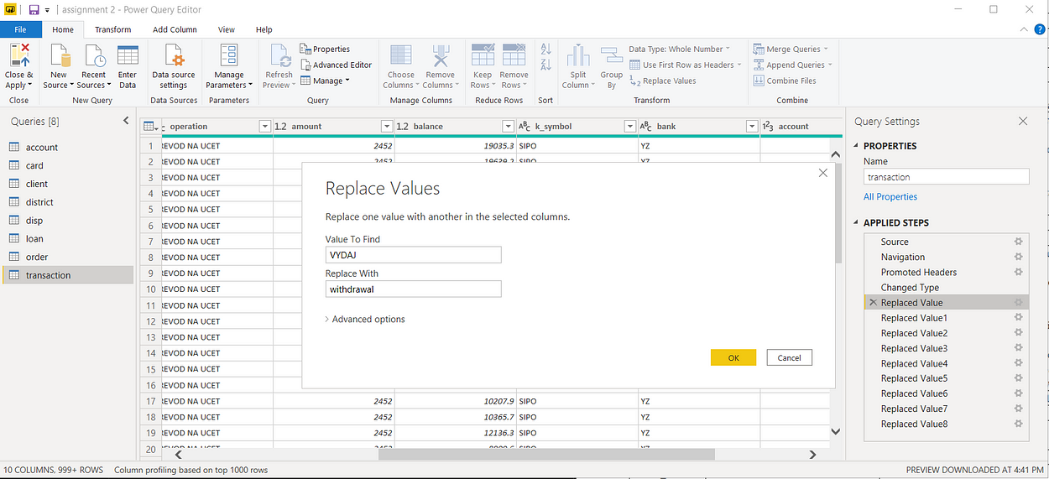



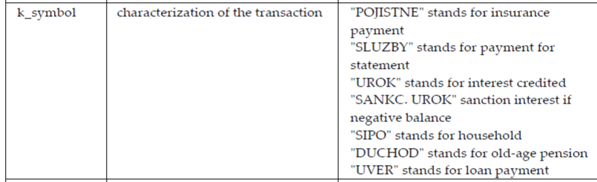

Changing the order of Region name at Power Query

Duplicate the “district /region” then split column using space as delimiter.

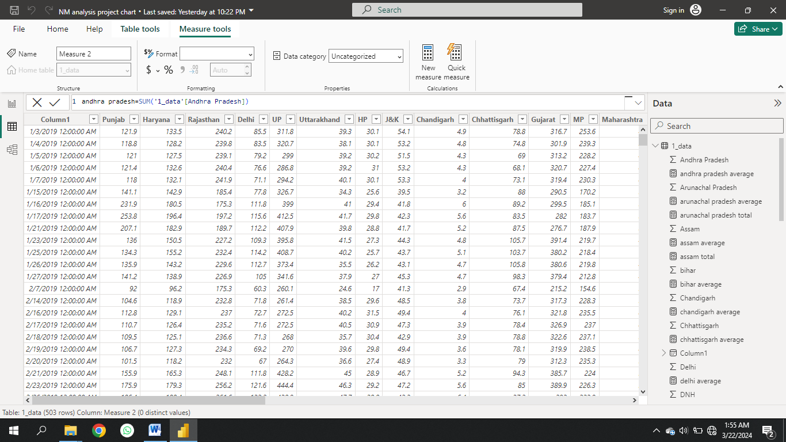

Then merge column by Region and direction. Refer to applied steps for details.

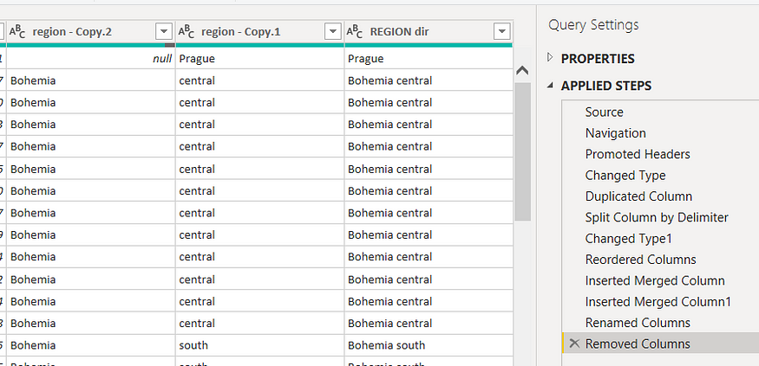

**Grouping of age by ranges**

As the customers’ age ranges from 12 to 88, we shall group them into different generation age range for easier profiling, we will group the ages into 5 groups.

The Gen Y are youths,

Gen X are young working adults, some starting their families

Baby Boomer are working adults with families.

The silent Generations some are working and retired, living on pensions.

The greatest Generation, retired elderly living on pensions.

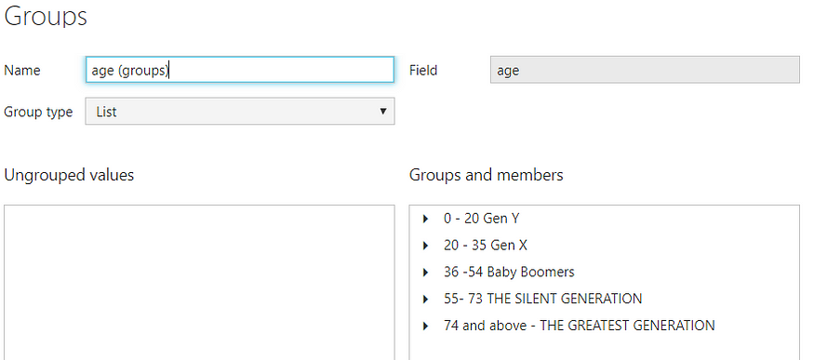

**Credit Rating and Loan Status**

As the Loan status uses A, B, C, D which are not reader friendly. We can add a column to represent what it stands for, we also simplify the classification of those with late or default on payment as bad credit, refer to the table below for details on the new columns added.

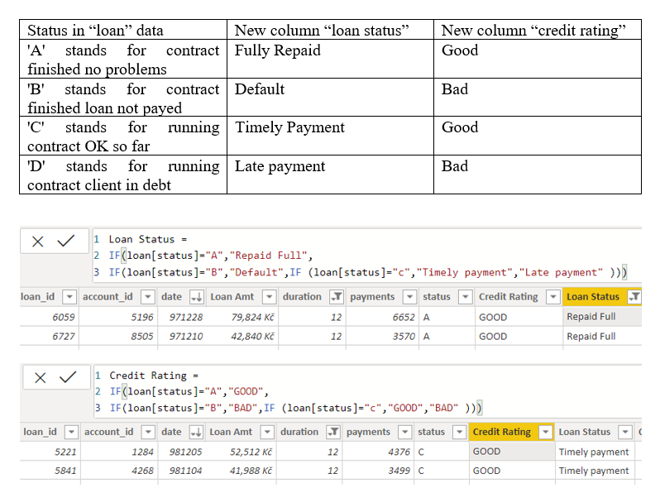

Values of such as “account Id” have also been set as Text.

And District name have been categorized as place to be use for the map to show the sum of the inhabitants in each region.

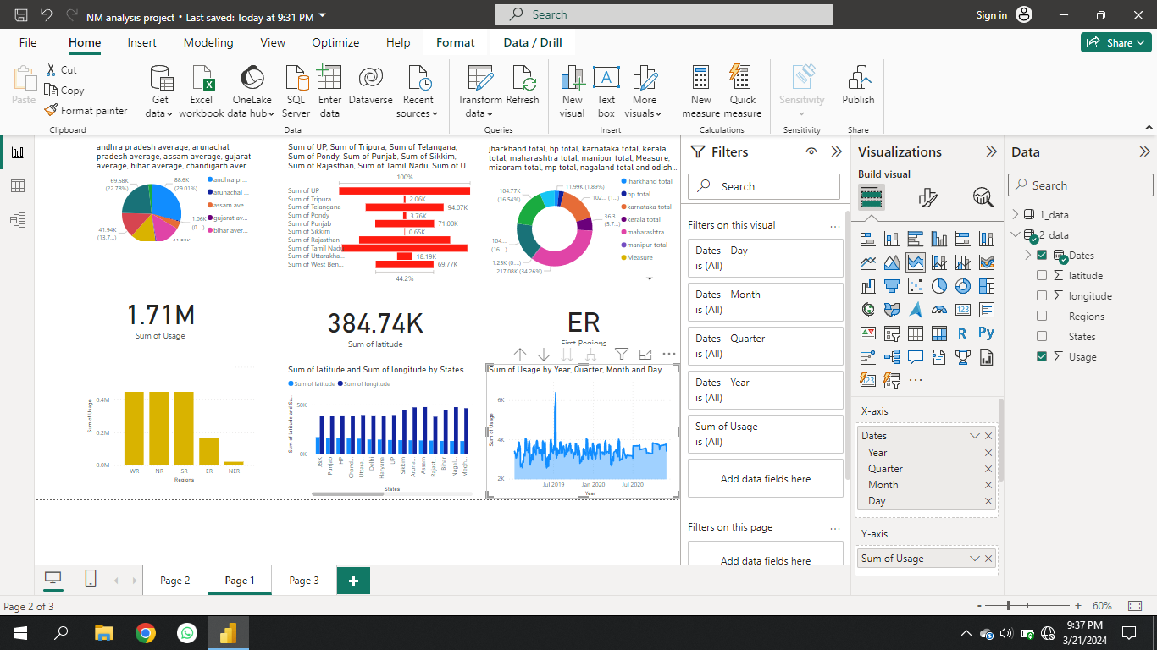

**Dashboard**



**CONCLUSION**

The project “Real-Time Analysis of Bank Customers” using PowerBI has successfully demonstrated the potential of data analytics in the banking sector. The real-time analysis of customer data has provided valuable insights into customer behavior, preferences, and trends, thereby facilitating informed decision-making. The interactive dashboards and reports have offered a comprehensive view of customer data, enabling the identification of patterns and correlations. This has not only improved the efficiency of data analysis but also enhanced the bank’s ability to provide personalized services to its customers. The project has also highlighted the importance of data visualization in making complex data more understandable and accessible. The use of PowerBI has made it possible to present data in a visually appealing and easy-to-understand format, thereby aiding in better decision-making.

Power BI reports serve as the foundation for dashboards, data exploration, and content collaboration and distribution in Power BI. Power BI Desktop provides data visualization features and options in abundance, enabling the construction of highly targeted and user-friendly reports across devices.

Power BI is a business intelligence and reporting tool that allows users to create intuitive reports. A growing number of organizations are using Power BI as their business analytics solution. According to Gartner’s report, by 2020, the compa-nies that are investing in analytics will see their value enhanced compared to those that are not. This chapter provides a summary of all the chapters covered in this book

**FUTURE SCOPE**

The future scope of this project is vast. With the advent of advanced analytics and machine learning, PowerBI can be leveraged to predict future trends based on historical data. Integrating these predictive analytics into the project could enable the bank to anticipate customer needs and proactively offer solutions. Furthermore, PowerBI’s capability to integrate with various data sources opens up the possibility of incorporating more diverse datasets for a more holistic view of customers. As data privacy and security become increasingly important, future iterations of this project should focus on implementing robust data governance strategies. This would ensure the secure handling of sensitive customer data while complying with data protection regulations. Additionally, the project could explore the integration of real-time data streams to provide even more timely and relevant insights. This could potentially transform the way banks interact with their customers, leading to improved customer satisfaction and loyalty.

Project scope is a way to set boundaries on your project and define exactly what goals, deadlines, and project deliverables you'll be working towards. By clarifying your project scope, you can ensure you hit your project goals and objectives without delay or overwork. Defining your project scope isn't a one-person job.

Project scope is the part of project planning that involves determining and documenting a list of specific project goals, deliverables, tasks, costs and deadlines.

**REFERENCES**

[https://www.researchgate.net/publication/261046177_Analysis_of_the_residential_commercial_and_industrial_electricity_consumption](C:\\Users\\ADMIN\\Downloads\\PowerBI Case Study Sample Report NM.docx)

**LINK**

<https://github.com/githubtraining/hellogitworld.git>